VPC Transit Gateway & VPC Endpoint
- Create one VPC, with 1 public subnet and 1 private subnet.
Create vpc:
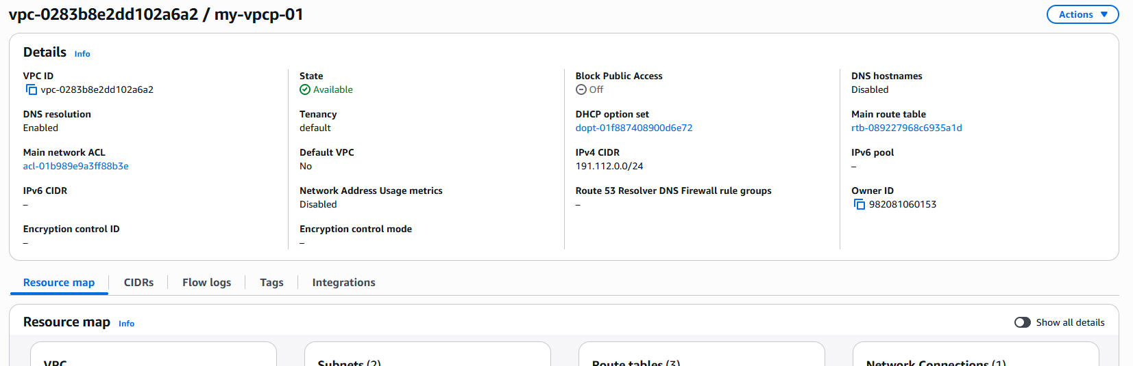
Create public and private subnet:
Create public route table and add public subnet add internet gateway:
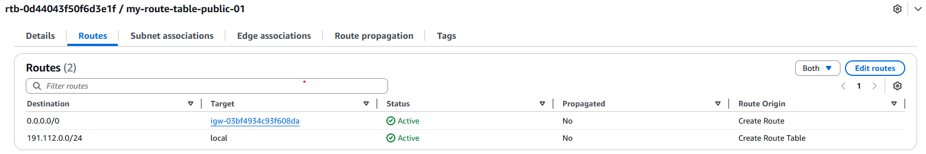
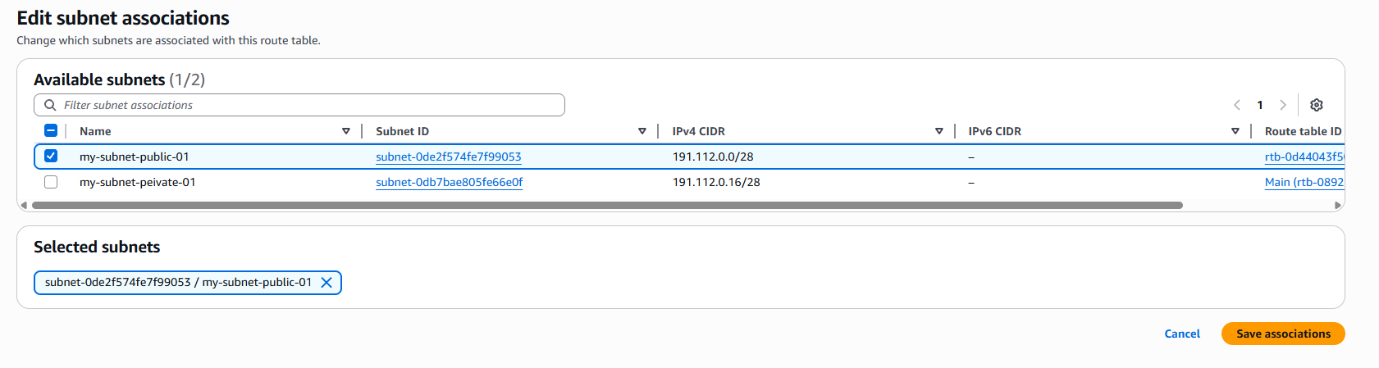
Create route table for private subnet without internet gateway.
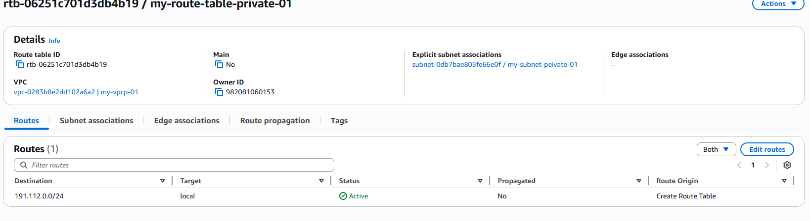
2.Enable VPC peering for cross-region.
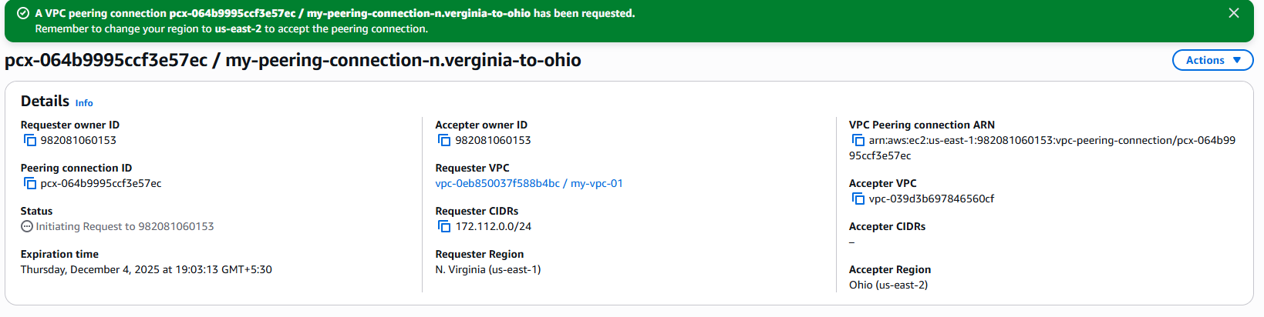
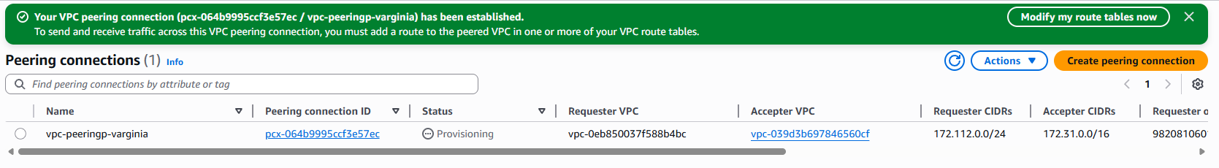
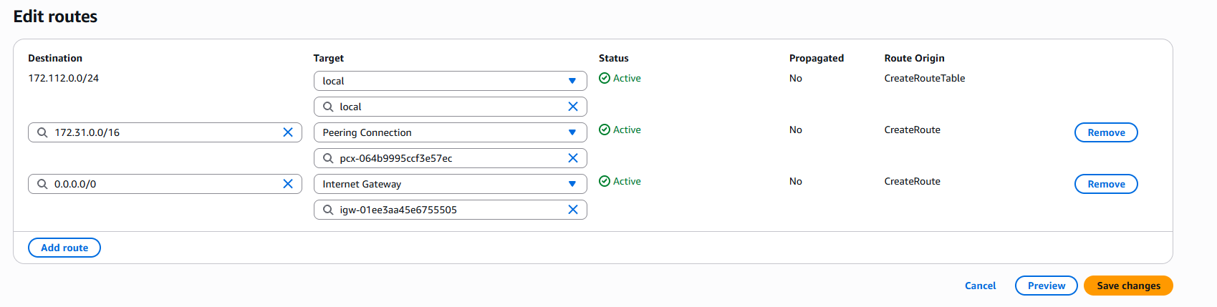
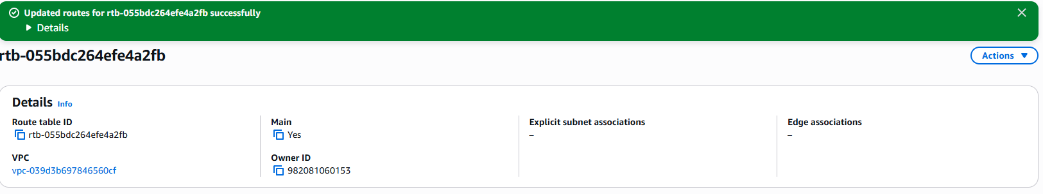
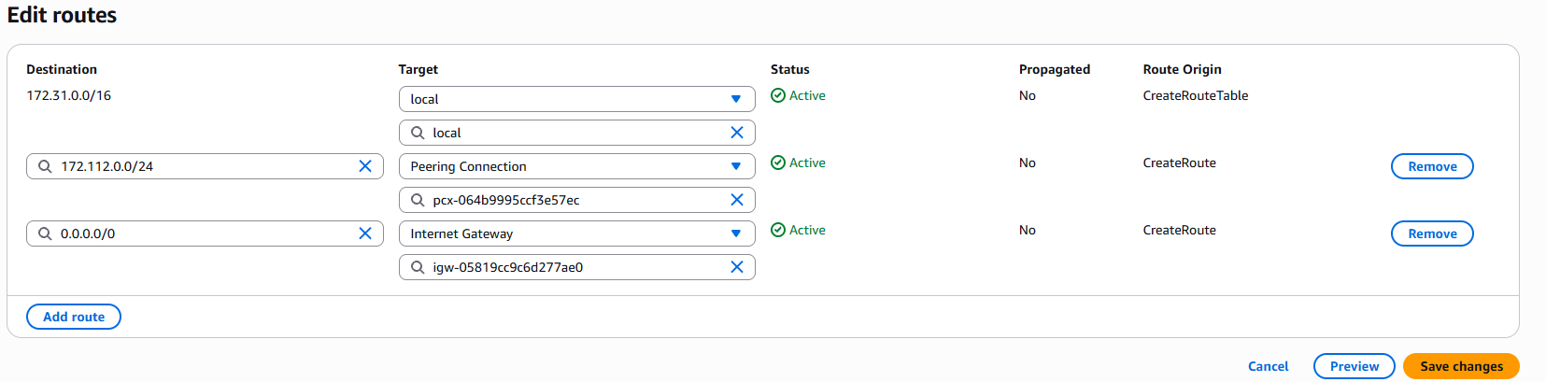

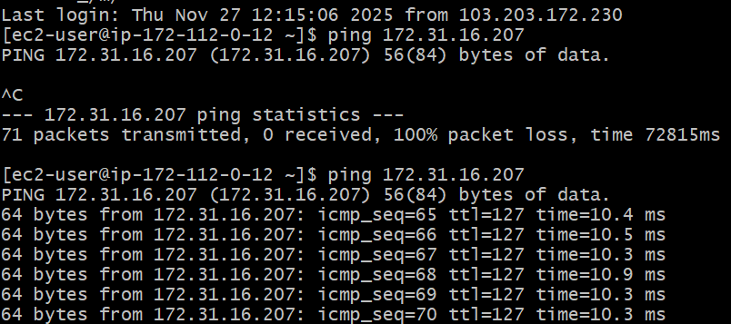

3. Enable VPC peering for cross-account (you can collaborate with your friend to do this task).
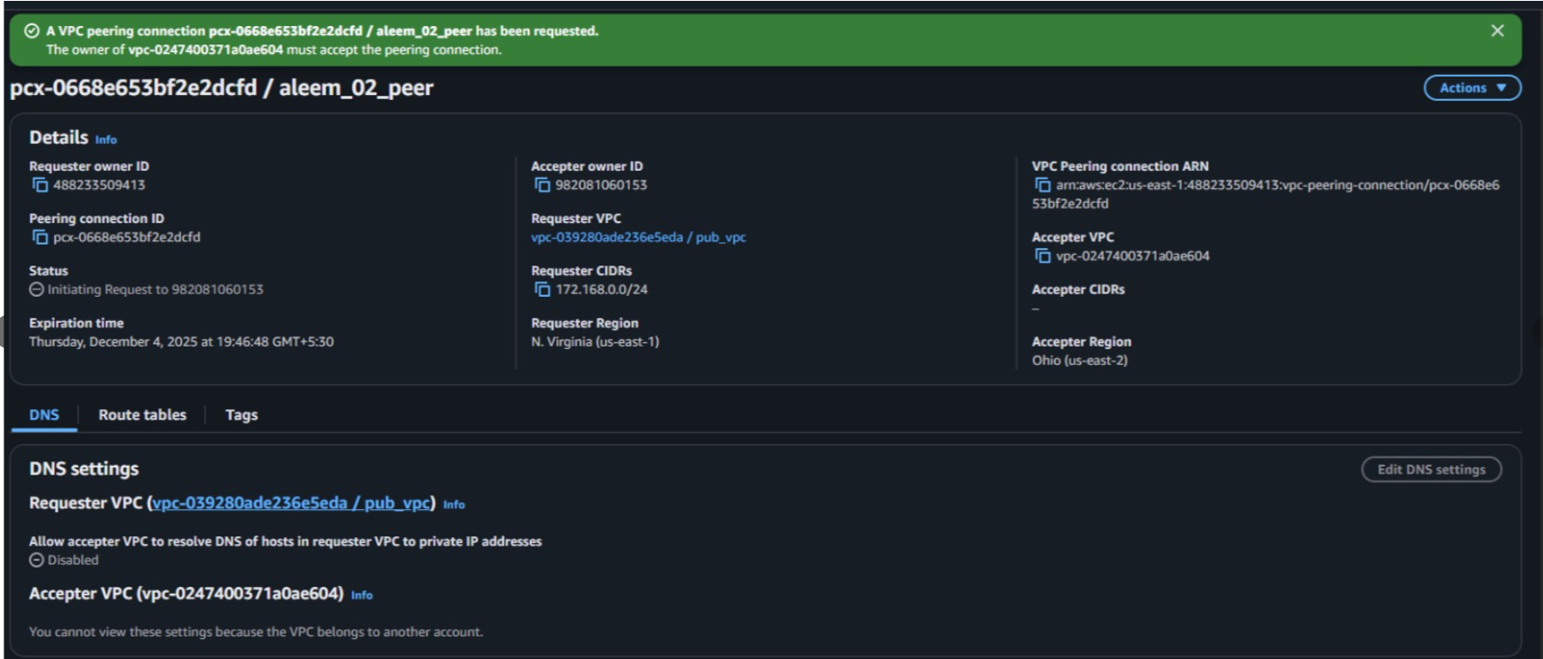
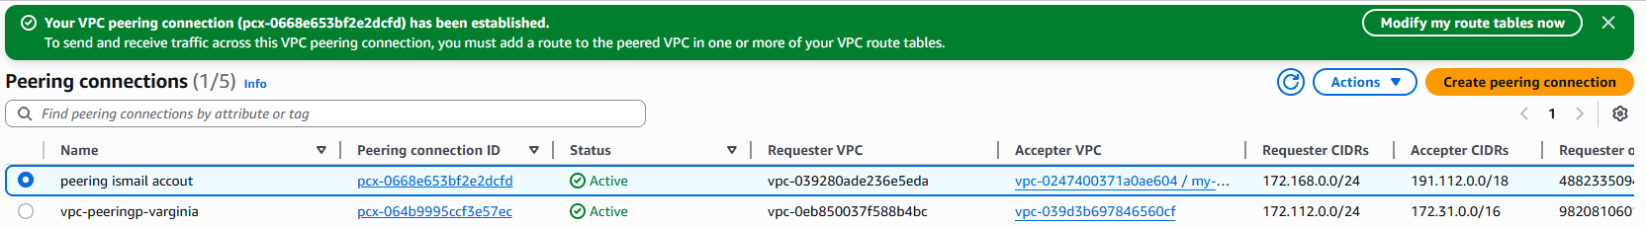

4.Set up a VPC Transit Gateway.
Create 4 vpc for transit gateway:
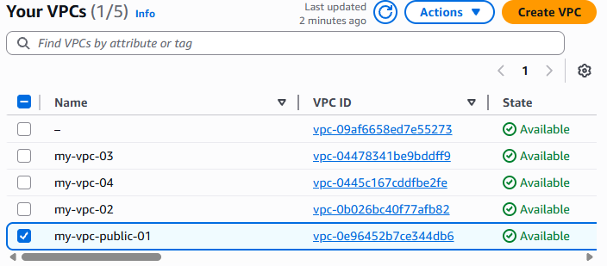
Create transit gateway and attached 4 vpc to transit gateway:

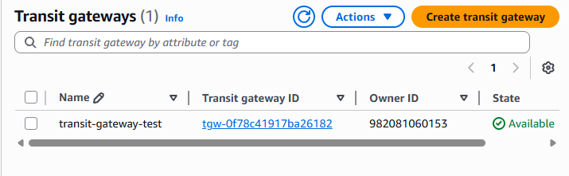
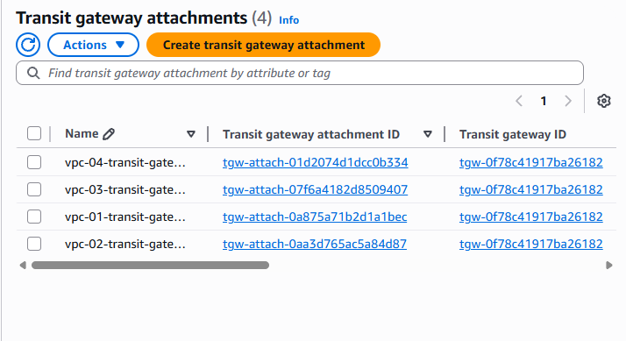
Add internet gate way in all four route table:
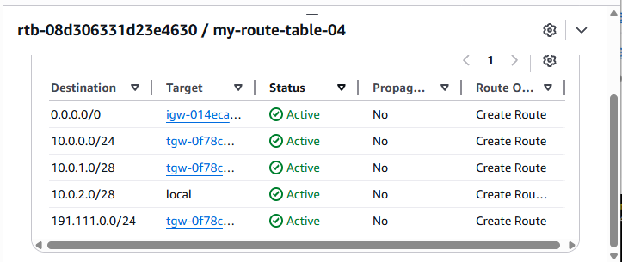
Edit inbound rules allow all traffic in ec2 security group inbound rules.
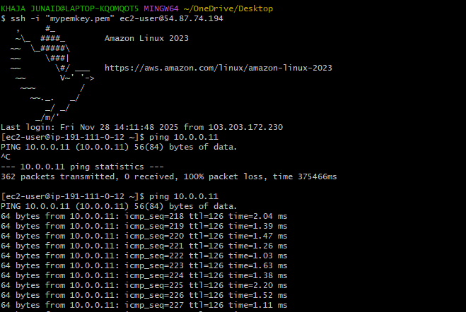
5.Set up a VPC Endpoint.
aws configure public instance:
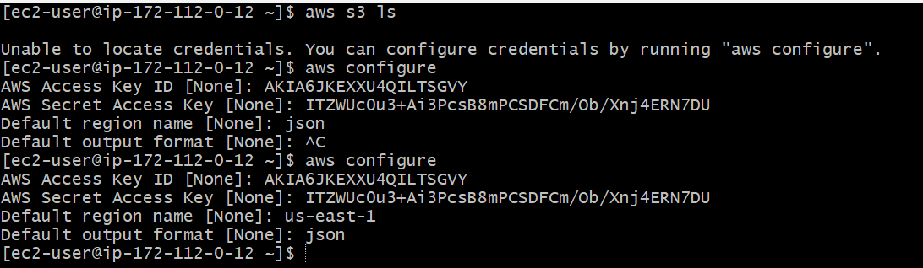
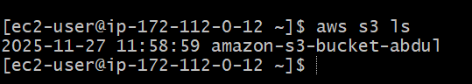

Aws configure Private instance using Vpc Endpoint
